This editable template helps your team easily and consistently share your School Food Authority’s (SFA’s) wellness policy assessment results. Input your SFA’s specific information, then download and save the customized document to your computer.

Follow these instructions:
- Select a reporting template (template 1 on page 2 or template 2 on page 3) listed in Document tabs

- Modify the document using the template specific instructions below:
  - Template 1
    - Add the School/District/RCCI name in the header and replace the LOGO placeholder with your school/district/RCCI's logo.
    - Replace the photo placeholder with a photo of wellness activities that your School/District/RCCI participated in (optional) or delete. Additional photos may be included on a second page but are not required.
    - Replace existing instructional text/placeholders under each header with the applicable information and the triennial assessment results summary.

  - Template 2
    - Add School/District/RCCI name, address, and phone number in the header and replace the LOGO placeholder with your school/district/RCCI's logo.
    - Replace existing instructional text/placeholders with the applicable information and the triennial assessment results summary.

- Click File > Download > PDF

- Print or save the customized document

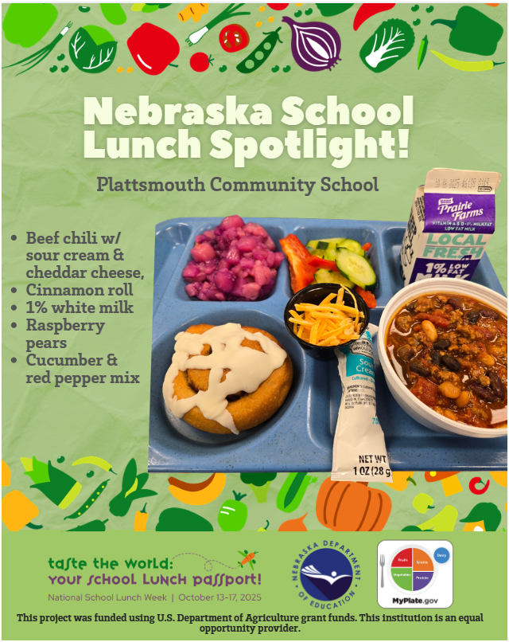

Triennial assessment

results 2026

Meet our team
- Tami Bracht
- Katie Strehle
- Paula Peatrowsky
- Lindsey Marr
- Krista Batenhorst
- Josh Batenhorst
- Jenna Vonnahme
- Mary Lueshen

Policy compliance results
Strengths:
a. During an NDE audit, we were told that we have a very good wellness policy. b. Many teachers are willing to help with input for the policy even if they aren't on the committee when brainstorming and data is needed. c. The community supports the wellness plan when students are walking to their business, making sure they have a safe plan for the walking route.
Areas for Improvement:
a. Do a better job monitoring food brought in for outside events like birthday treats. b. Brainstorm for more opportunities for the upper grades to add activity during the school day. c. Continue to look for more new activities, especially in the upper grades as they don't have scheduled recess or other breaks for activities.

Wellness policy goals
- Nutrition education/promotion
- Physical activity
- Other goals for student well-being

https://1drv.ms/w/c/0fadaa26bcd07ddf/IQDjsGG7kv5mT7aVcFTzxuawAQ6lHSZ57Bc3cj6g-riRI84?e=4%3ajixHY3&sharingv2=true&fromShare=true&at=9

Key achievements
- Have improved on adding more physical across all grade levels, have improved on monitoring food and drink brought into the buildings, both the older students and the younger students with birthday treats.

Next Steps
Continue to add physical activities and monitor all outside foods brought in.

2/5/2026

Guardian Angels Central Catholic Community,
Guardian Angels Central Catholic takes pride in supporting the needs of the whole child, and to ensure that all children are safe, supported, engaged, and challenged each school day. Research indicates that initiatives focused on improving aspects of students’ well-being in schools — such as addressing childhood obesity, preventing bullying, supporting students mental health, and restricting use of exclusionary discipline — have been found to be successful in improving student success and academic excellence. We have assessed our wellness policy as part of the USDA requirements. Below are the results of our assessment.

Step #1- This step lists the strengths, new goals and opportunities for improvement. They are all listed in the new policy. The main goals for this updated policy were to monitor outside foods brought into the buildings better and add more physical activities during the day for the older students.

Step #2- This step asks for the progress made towards these goals. As this is the start of reaching these goals, the completed goals haven’t been made yet but the documentation towards the expectations has begun.

As we make more progress the updated police will be posted on the school website.

The current Local Wellness Policy meeting the Triennial Assessment requirements for 2026 can be found on the school website at www.gaccbluejays.org using the following path on the home page. There is a tab on the home page, “About GACC” with a link to the hot lunch program under that tab. All of the lunch program documents are located there including the Local Wellness Policy.

If you have any questions, please contact Tami Bracht @ gaccbluejays.org

Respectfully,

GACC Wellness Committee

